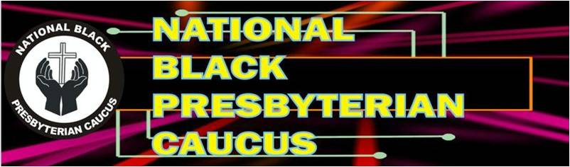
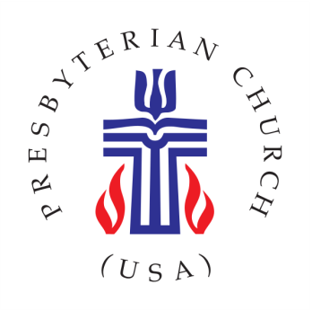
Spring Edition 2018

From the President

Since the last publication of our newsletter we have sat, stood and lain, listening to the words of Jesus, our Savior, as he mused over what was to make history because of him. We heard him tell who he was:
Again Jesus spoke to them, saying, “I am the light of the world; he who follows me will not walk in darkness, but will have the light of life.” I am the good shepherd. The good shepherd lays down his life for the sheep.
(John 8:12, 10:11)

We heard the Master described what was going to happen to him in Jerusalem as he journeyed there.
“Behold, we are going up to Jerusalem; and the Son of man will be delivered to the chief priests and scribes, and they will condemn him to death, and deliver him to the Gentiles to be mocked and scourged and crucified, and he will be raised on the third day.” (Matthew 20:18-19)

We witnessed Jesus’ trial and death sentence, coming as a result of false testimonies and spineless prosecutors. We saw where his body was placed and the empty tomb.

We heard the Lord’s command and promise
Go therefore and make disciples of all nations, baptizing them in the name of the Father and of the Son and of the Holy Spirit, teaching them to observe all that I have commanded you; and lo, I am with you always, to the close of the age.” (Matthew 28: 19-20))

Now, Jesus is speaking directly to us, despite whom and what are competing to quell his command and make light of his promise. We are commissioned to go and make a difference in God’s world, doing thus in our local congregations and individual communities, which all being integral components of the Church of Jesus Christ.

These acts should occur because of the urgent needs. We have the God endowed resources, including most of all, the eternal presence of the Resurrected Lord who promised, “I will be with you always, to the close of the age.”
(John 4:35d-f)

George M. Wilson, President
Presbytery of the Peaks, NBPC
PRESBYTERY OF THE PEAKS BLACK CAUCUS AWARDS SCHOLARSHIP

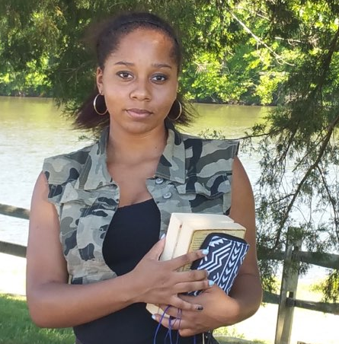
The Black Caucus for Presbytery of the Peaks is pleased to announce a $500 scholarship award to Miss Charity Hope Walton.

Ms. Walton is a senior at Randolph-Henry High School in Charlotte Courthouse, Virginia and she is an active member of Gethsemane Presbyterian Church located in Drakes Branch, Virginia. Charity has maintained a 3.6 average and she is an active participant in projects that support her community. She will be attending Southside Virginia Community College in the fall. Her parents are Ms. Dorothea Sizemore and Mr. Darrell Walton.

Rev. George Wilson, President of the Presbytery of the Peaks’ Black Caucus said that it is with pleasure that we will be giving this scholarship to such a deserving student and look forward to working with her over the years as she continues her education. The Black Caucus wishes Charity the best and this scholarship will be presented to her at her church in June of this year.

What’s Happening Around the Peaks
Community Outreach Block Grant Awards 2018
The Presbytery of the Peaks has funds budgeted for Block Grants each year. These are for local community organizations such as tutoring programs, clinics, adult care, jail ministry or other community care programs. The money for these grants is dispensed by the Grant Workgroup of the Mission Committee. Grant applications are due February 1. $43,500.00 was awarded in February 2018.
Fifth Avenue PC submitted a Block Grant proposal on behalf of two local agencies in Roanoke. Fortunately, the proposals that were submitted were awarded to the following agencies
TAP/Early Head Start / Roanoke $1,000.00 Virginia Blue Storm / Roanoke $1,000.00
ADVENTURE CAMPS
Middle School Adventure Camp:
Registration Price: $213
Please register by June 1, 2018
June 17-22 (rising 6th—8th graders)
Sunday 4:00pm through Friday 6:30pm.
Adventure Camp has your perfect mix of wild fun and discipleship activities. You will live in cabins on main campus, and then spend each day in a co-ed family unit of 10-12 campers with 2-4 counselors. Activities for the week include group games, nature, crafts, music and singing, campfire vespers, swimming, low-ropes group challenges, creek-play, Home-in the-Woods camping skills, hiking the camp trails and a singing hike to Horseshoe Bend, archery, orienteering and geocaching, slacklining, 9-Square-in-the-Air, Gaga Ball, Morning Watch, Bible study, a morning of tubing on the James River (described below), a half-day canoe trip on the James River (described below), Horseback Riding (described below), polar bear swims, night activities, special all-camp programs and a day on the climbing wall and high ropes course! Tuesday or Wednesday your family unit will have a cookout in your Home-in-the-Woods and have one or more overnight camp-outs (see opt-out info below). A specific letter and gear guide will follow your sign-up. This is a great week of spiritual development, fun and adventure; exploring your extraordinary faith journey and learning TOGETHER. Be here for an awesome week! For full details: https://www.campbethelvirginia.org/potp-middle-school-adventure-2.html
Senior High Adventure Camp
Registration Price: $198
Please register by June 1, 2018
June 17-22 (rising 9th—12th graders)
Sunday 4:00pm through Friday 6:30pm.
It’s our best week of camp fun and intense Christian living specifically geared toward teen life. Adventure Camp has your perfect mix of wild fun and discipleship activities. Adventure Camp is for active youth who enjoy the outdoors. You will truly live as a Christian body in a co-ed Unit of 6-12 campers with 2-4 counselors in our creek-side Adventure Village in our vast and beautiful riparian forest. Each A.V. includes a boys’ hut, a girls’ hut (both with bunk beds & mattresses & personal screening) and your dining shelter with fire circle, all by the clean waters of Wilson Creek. You’ll eat most meals in the Ark, swim in the pool, attend all camp events, and have access to all the amenities of the camp (including showers!). Activities for the week include group
games, nature, crafts, music and singing, campfire vespers, swimming, low-ropes group challenges, creek-fun, hiking the camp trails and a singing hike to Horseshoe Bend, archery, orienteering and geocaching, slacklining, Gaga Ball & 9-Square, Morning Watch, Bible study, daily “Voice Your Choice” Unit activity, polar bear swims, night activities, special all-camp programs and a day on the climbing wall and high ropes course! Your week also includes 3 days of adventure outings: River Tubing; River Canoeing, and Caving! (See descriptions below). A specific letter and gear guide will follow your sign-up. This is a great week of spiritual development, fun and adventure; exploring your extraordinary faith journey and learning TOGETHER. Be here for an awesome week!
For full details: https://www.campbethelvirginia.org/potp-high-school-adventure-2.html

Please encourage your youth to consider registering for one of the camps. Representation from our Black Caucus churches is minimal. Maybe your church could provide scholarships to encourage our youth to enroll.



Synod of the Mid Atlantic Highlights March 12 -13, 2018
The following highlights may be of interest to our NBPC Churches:

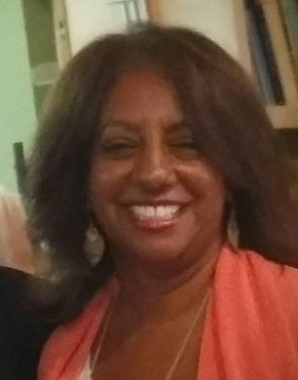
The Catawba Story is also new to many; however, for Veronica Cannon this story is real talk. On October 6, 1866, the Catawba Presbytery was organized just after the end of the Civil War. Northern missionaries saw the newly liberated African Americans as objects of mission and began to evangelize. Hence, congregations were organized; presbyteries were created as well as synods related to the Northern Presbyterian Church. In 1887, the General Assembly organized the Catawba Synod which would be made up of the presbyteries of Catawba, Cape Fear, Yadkin and Southern Virginia. Since its inception, Catawba had strong ties to Johnson C. Smith and Barber Scotia College. These institutions of higher learning prepared men, women and young people for leadership in Black Presbyterian Churches and communities. The churches, presbytery and synod produced prophetic Presbyterian Leadership. Men and women were catapulted into civil rights leaders. Many became ardent advocates for social justice changes. However, with the 1983 Reunion of the PCUS and UPC, these presbyteries and synod were dissolved. Restructuring lead to African Americans feeling a loss of their voices and clearly diminished their presence and participation. Racial Ethnic ministries ended, mission functions ended and advocacy groups lost their seats on the council. Cannon challenged Commissioners to restore the lost voices, fund educational opportunities to help African Americans leaders to become stronger in their communities and across the denomination. Several commissioners bore witness to her presentation as they were alums of Scotia and Smith and/or products of churches that came out of Catawba or a similar history.

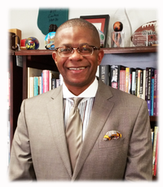
Jerry Cannon is an effective practitioner in ministry and is Senior Pastor of the largest African American Presbyterian Church in the Synod and possibly the PCUSA. Jerry knows a lot about rationales for a new African American initiative. In fact, he is a walking and living history for the impact of the Catawba Presbytery and Synod. Jerry was the last Teaching Elder to be ordained by Catawba Presbytery. His sister, Rev. Dr. Katie Cannon, is the first African American female to be ordained in the Presbyterian Church by Catawba Presbytery. Jerry’s presentation focused on providing a rationale for this new initiative. He charged the assembly to invest in the Next Generation of African American Leaders. He provided 10-key poignant themes: (1) Point the Next Generation of Christian Leaders to God, 2) Make them our primary focus, 3) Be in it for the Long Haul, 4) Allow for mistakes, 5) Foster authentic and long lasting relationships with them, 6) Teach them Structure and Orderliness, (7) Investing in the Next Generation requires hard work and financial investment, (8) Be prepared to step aside for the next generation but work alongside of them, (9) He stressed the importance of accountability and for all of us to hold each other accountable in terms of spiritual discipline and recruitment, and (10) Finally, he encouraged all to engage in the discipline of Prayer.

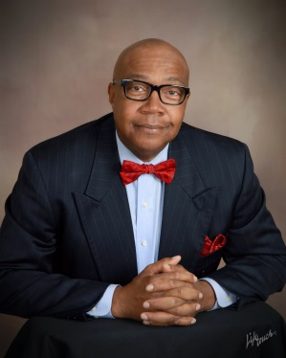
Synod Stated Clerk reported that the PCUSA Freedom Rising Pilot Initiative is taking specific action to confront the societal and racial issues facing black communities in the U.S. by living into a new church initiative to address the plight of African American males in our country.

Unfortunately, no news items from our Black Caucus member churches were received in time for the Spring edition of the Colorful Peaks. Hope there will be more news received for the Summer Edition.

With Easter over, Christians are looking forward to another important celebration in church history – Pentecost. You've probably heard about this, but what is it really all about? Why do Christians celebrate Pentecost and what does it mean for us?
Pixabay

What is Pentecost?
Pentecost is a Christian festival celebrating the gift of the Holy Spirit. Jesus sent the Holy Spirit to his disciples to help them in their faith, and continue their work of establishing the church and spreading the gospel further. Pentecost is also known as the birthday of Christian faith. Additionally, the word "Pentecost" comes from the Greek word "pentekoste," which means "fiftieth."
When is Pentecost 2018?
The date of the Pentecost varies every year as it takes place 50 days after Easter, so for 2018, it will be on May 20. In many countries, Pentecost is considered a secular public holiday.
What does Pentecost mean for Christians?
The significance of Pentecost lies in the baptism of the disciples with the Holy Spirit. Jesus made the promise in John 14:26 saying "But the Helper, the Holy Spirit, whom the Father will send in my name, he will teach you all things and bring to your remembrance all that I have said to you." After dying on the cross and being resurrected, Jesus reappeared in front of the disciples to prove He was alive and well. He told them to wait in Jerusalem.
Come Pentecost, the disciples were waiting in an upper room in Jerusalem, bonded in prayer together when they heard the sound of a strong wind inside the house. This was the Holy Spirit and they were filled with it. They were given the gift of tongues. Immediately, Peter began his ministry, while the other disciples also spread the word, giving way to the birth of the church.
Nowadays, Pentecost Sunday is a celebration of the gift of the Holy Spirit. This holiday unites Christians together. It reminds Christians that, we too can receive the gift of the Holy Spirit and be witnesses to the ends of the Earth.
Other things you should know about the Pentecost
On Pentecost Sunday, most people will be wearing crimson or deep red. This is the color of Pentecost. However, for Catholics, they call this holiday Whitsunday, which comes from the words White Sunday. The white color symbolizes the color of the garment used when people are baptized. Additionally, in some countries, the church likes to do Confirmations on this day. This practice gives the young people responsibility for their own faith, which makes sense as the birthday of the church is all about inviting more people to join it.
Do be reminded that being a witness of God doesn't need to take place on Pentecost Sunday only. You can be His witness and spread the gospel every day of the week.

Future Meetings of the Presbytery of the Peaks Dates
Saturday, August 18, 2018
Trinity Ecumenical, SML
Thursday, Nov. 15, 2018
First Pres, Danville

Safe travels to St Louis, Missouri to the Presbyterian Church USA General Assembly meeting June 11 -23, 2018!

DEADLING FOR ARTICLES
June 30, 2018
Send information to:
Joyce A. Bolden
925 McDowell Avenue NW
Roanoke, VA 24016
Email: akajab@aol.com
Phone: 540-345-8432
Please do not send PDF files!

PEACE & BLESSINGS

